
Procedure 2025

ArcelorMittal Building Solutions France Procedure 1.1.1.8

ATRADIUS credit application

MAIN POLICY CREDIT APPLICATION
  - Customer search

è Login to Atradius website: Atrium | Credit Management
è Select the AMCF policy:
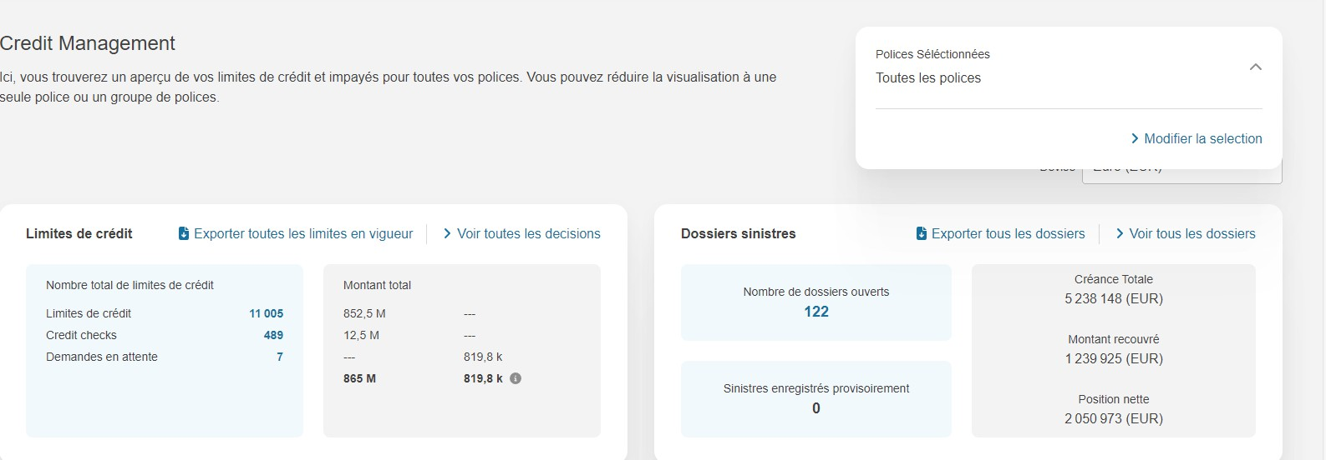

è Search for policy number 681822 and select the policy:
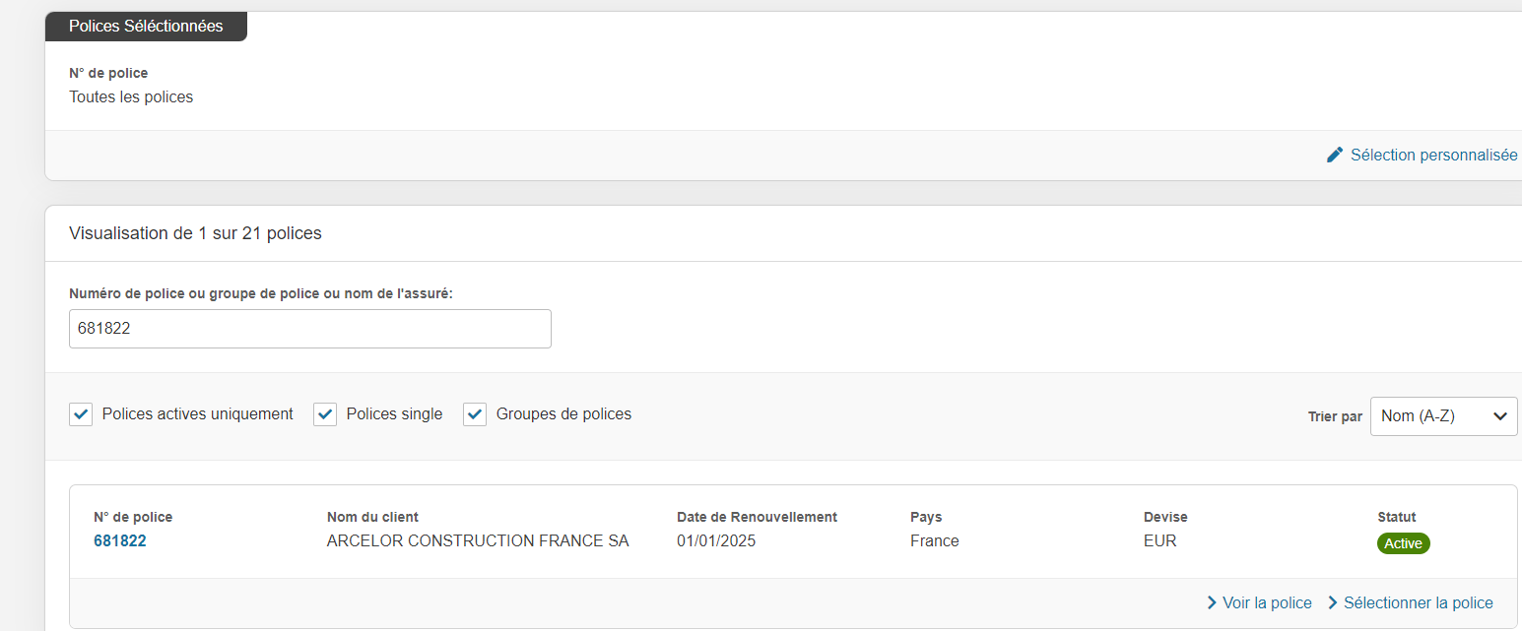

è Search for a customer :
Select the corresponding country and search for the customer by Atradius number, VAT number or SIREN number, then Enter.



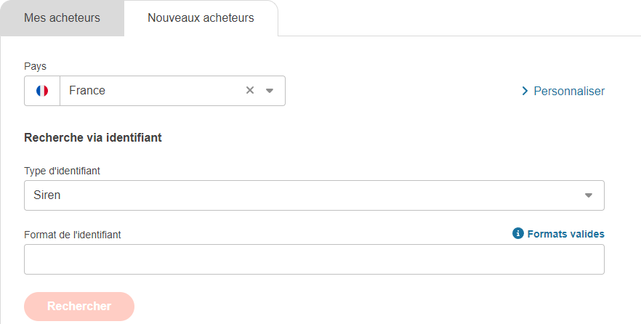

  - Credit application

è Request cover :
Enter information concerning credit amount, type of cover: credit limit and reference: SOFIE code + applicant's INITIALS
Then send the request



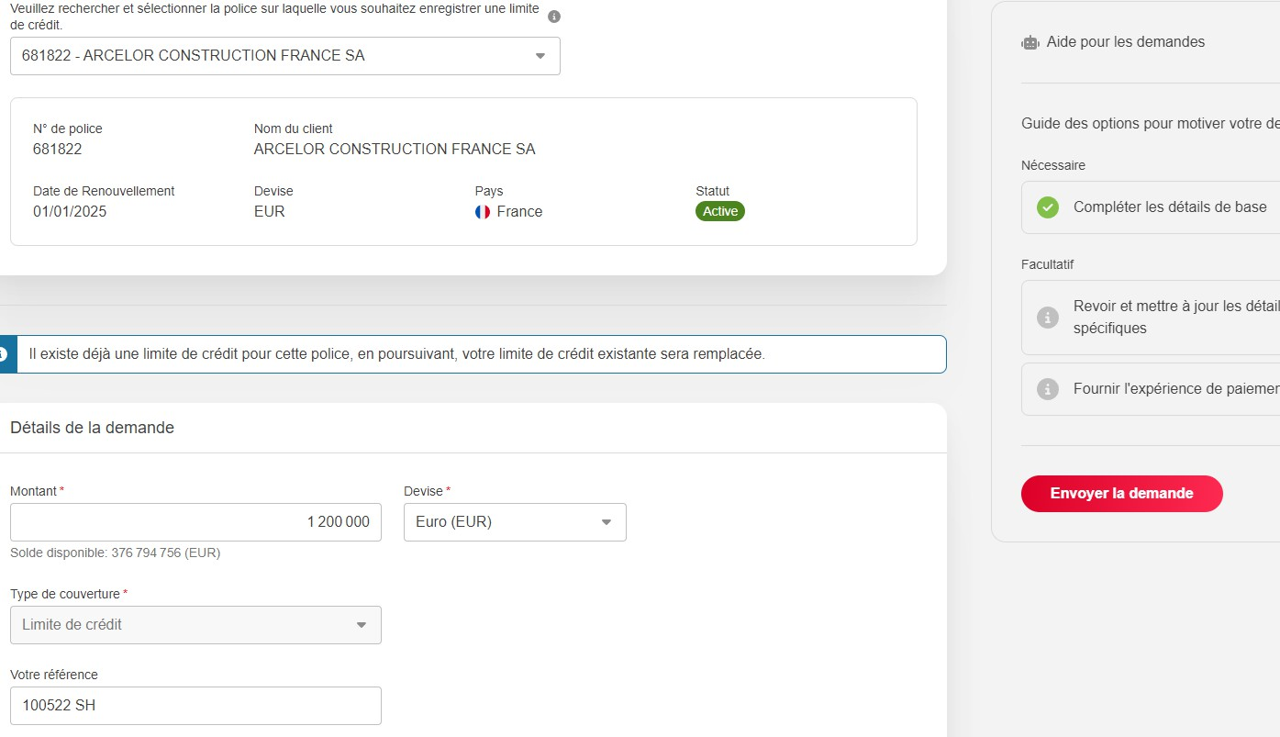

CREDIT APPLICATION WITH BALANCE SHEET

è Go to more information and download documents

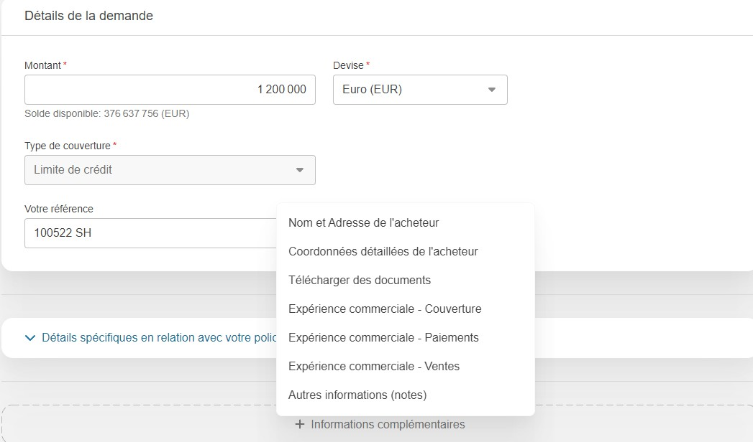

è Enter document type and closing date. Then download the document and send the request

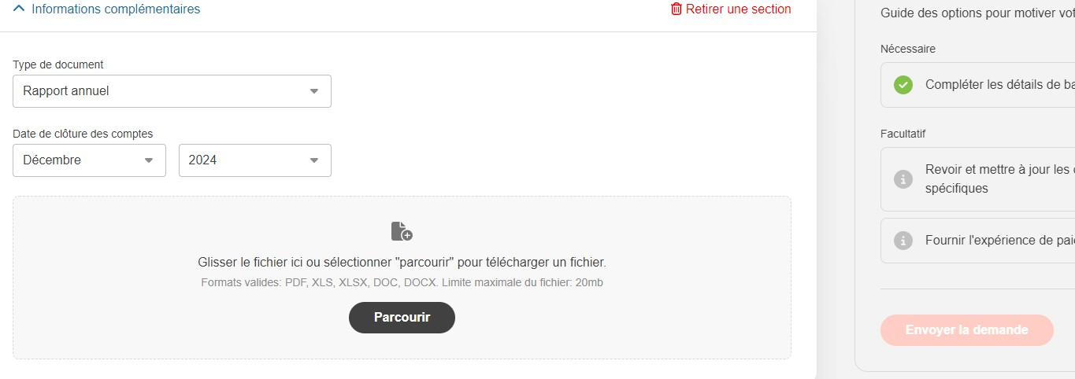

- CAP / CAP + CREDIT APPLICATION

è Select the CAP AMBS France policy:
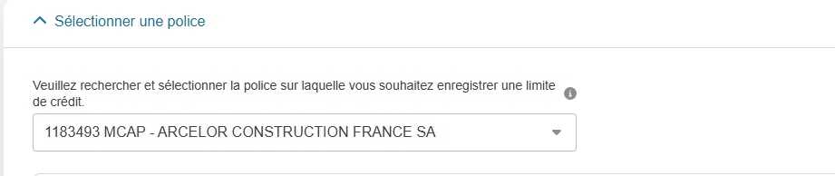
è Apply in the same way as for the main policy

è Add a comment and fill in the AMBSF 681822 font:
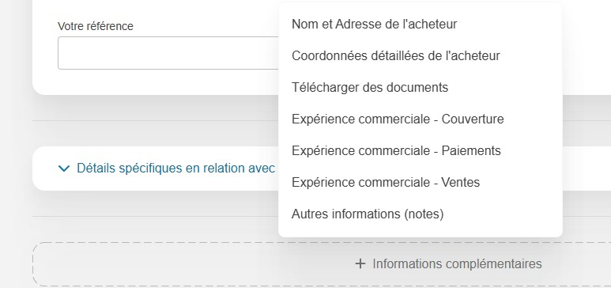

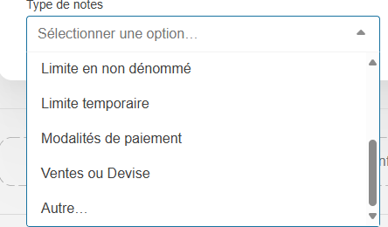
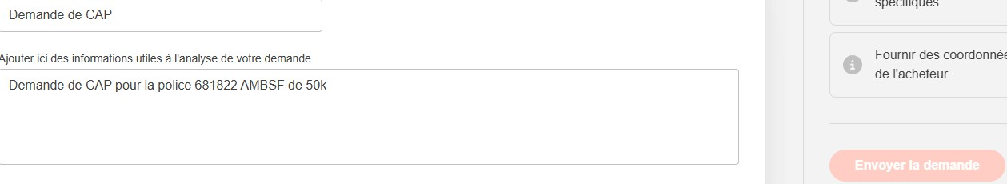
è Complete the CAP / CAP + table:

Fill in all table columns

ARCHIVE ATRADIUS ENDORSEMENT

Save the rider received in the customer credit mailbox as an attachment under the N in the customer's folder, in this example account 100522 and in the "Credits" and "Atradius" folders.
Format to be used: Endorsement YYYY/MM/DD amount accepted/refused/maintained
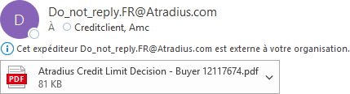

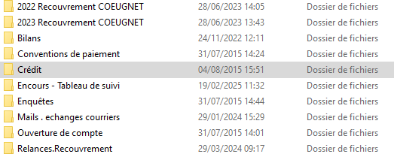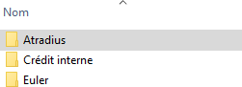

SOFIE COMMENT

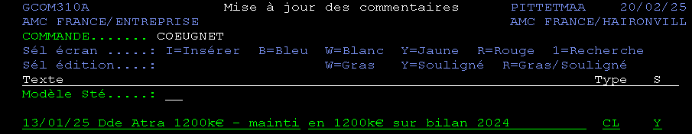
Go to Sofie 03-01-05-01, enter the customer's Sofie number. Then F10 to update the Sofie comment:

Format to be used: Date of comment, request at X with amount, accepted/refused/held, reasons
Blue B = request in progress Yellow Y = decision received
Red R = credit modification/cancellation

On: 03/11/2025
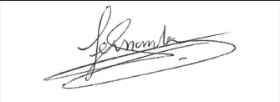
Procedure validated by : S. HERNANDEZ

